COURSE CODE: VPR 404
COURSE TITLE: VETERINARY PROTOZOOLOGY
NUMBER OF UNITS: 2UNITS
COURSE DURATION: 1 HOUR (L), 3 HOURS (P)

COURSE DETAILS:
COURSE DETAILS:
Course Coordinator: DR (MRS) F.A. AKANDE
Email: akandefa@unaab.edu.ng
Office Location: GLASS HOUSE, COLVET BUILDING
Other Lecturers: PROFESSOR B.O. FAGBEMI

COURSE CONTENT:

DIAGNOSTIC MORPHOLOGY, LIFE CYCLE, TRANSMISSION, PATHOGENICITY AND CONTROL OF PROTOZOA OF VETERINARY IMPORTANCE INCLUDING ARTHROPOD-BORNE (TRYPANOSOMA, BABESIA, ANAPLASMA, THEILERIA, HAEMOBARTONELLA, PLASMODIUM, LEISHEMANIA) AND THOSEWITH DIRECT LIFE CYCLE (EIMERIA, ISOSPORA, TOXOPLASMA, BESNOITIA, ENTAMOEBA, TRICHOMONAS, BALANTIDIUM AND GIARDIA).
COURSE REQUIREMENTS:

Compulsory
READING LIST:

- EJL SOULSBY, HELMINTHS, ARTHROPODS AND PROTOZOA OF DOMESTICATED ANIMALS. 7TH EDITION. LONDON, UK BAILLIERE, TINDALL 1986.
- URQUHART, G.M., ARMOUR J., DUNCAN J.L. ,DUN A.M., JENNNINGS F.W. VETERINARY PARASITOLOGY 2ND EDITION 2003.
- DWIGHT D. BOWMAN, GEORGIS’ PARASITOLOGY FOR VETERINARIANS. 8TH EDITION 2003.

E
LECTURE NOTES

CLASS COCCIDIA
Families
- Eimeriidae intracellular parasite of intestinal epithelium
- Sarcocystidae
OOCYST: Oocyst wall in composed of two layers & in generally clear and transparent in a well- defined double outline. It may be somehow yellowish / green in color in some spp.
- Identification may be by :
- Shape - spherical, ovoid/ellipsoidial.
- Refractile shell and some spp possess a small pore @ one end (micropyle) which is often covered by a polar cap in may be prominent.
- COCCIDIA
These organism are intracellular parasite of the epithelial cells except few exception.
Eimeria stidae (liver of rabbit)
Eimeria truncata (kidney of geese)
They have a single host in which they undergo asesual and sexual multiplication.They are host specific and tissue tropic.
The macro and microgamonts develop independently, the latter producing many gametes.
A zygote results from their union and by a process of sporogony, a variable number of spores (sporocysts) which contain 1/ more sporoiten are formed. Sporogony occurs outside the host. members of the family can be differentiated by the numbers of sporocysts and sporoziotes, they possess.

Sporocysts sporoziotes
Tyzzeria 0 8
Isospora 2 4
Eimeria 4 2
Wenynella 4 4
4 (not enclosed in any sporocyst)
Cryptosporidium 4
COCCIDIA LIFE CYCLE
Can be divided into 3 phases
- Sporulation
- Infection and schizogony
- Gametogony and Oocyst formation.
SPORULATION
Unsporulated Oocysts are passed out in faeces. Under suitable conditions (Oxygenation and optimal Temprature (27ºc): the nucleus divides twice and the protoplasmic mass forms conical bodies radiating from a central mass.
Each of these nucleated cones becomes rounded to form a sporoblast. While in some spp the remaining protoplasm forms the Oocysts residual body.
Each sporoblast secretes a wall of refractile material and become sporocysts while the protoplasm with in divides into 2 banana - shaped sporoziotes
Time taken for these changes varies according to Temperature but under optimal condition it taken 2-4days.
The oocyst now consisting of an outer wall enclosing 4 sporocysts each containing 2 sporozoites is called. A SPORULATED OOCYST within an infective stage
INFECTION AND SCHIZOGONY (ASEXUAL REPRODUCTION)
The host becomes infected by ingesting the sporulated oocyst. The sporocysts are then liberated either mechanically or by CO₂ the sporozoites activated by trypsin and bile leave the sporocyst. In most spp each sporozoite penetrates an epithelial cell, rounds up and become a trophozoite.
After a few days each trophozoite has divided by multiple fission to form a schizont which contain a large number of elongated nucleated organism – merozoites: when division in complete and the schizont is mature, the host cell and the schizont rupture and merozoites escape to invade neighboring cells schizogony may be repeated, the no of schizont generation depending on the spp.
GAMETOGONY AND OOCYST FORMATION
Asexual reproduction (schizogony) terminates when the merozoites give rise to M and F gametocyte Factor responsible for the switch are not known fully.
Macrogametocytes are Female and remain unicellular but increase in size to fill the parasitized cell. They are different from a trophozoite/developing schizonts by the fact that they have a single large nucleus.
The M microgametocytes each undergo repeated division to form a large no of flagellated uninucleate organism – microgametes
Microgametes are freed by rupture of the host cell, one penetrates a macrogamete and fusion of their two nuclei occur. A cyst wall is formed around the resultant zygote known as OOCYST. There in no further Development until this Unsporulated Oocyst is liberated from the body in faeces.
PPP varies: 5 days in poultry/ 3-4weeks in some rumminant spp
ISOSPORA
Genns contains many spp and parasitises a wide range of hosts. Differences in isospora life cycle compare to Eimeria:
- Sporulated oocyst contains 2 sporozoites
- Extraintestinal stages seen in spleen, liver and lymph nodes of the pig may reinvade the intestinal mucosa and cause clinical signs.
- Rodents may, by ingestion of oocyst from dog and cats become infected with asexual stages and act as reservoirs.
COCCIDIOSIS OF LIVESTOCK
CATTLE
Affects cattle under I yr but is occasionally seen in yearlings and adults.
Spp : Abt 13 have been recorded.
Strain (a) Eimeria zuernii (b) E. bovis
(c) E. alabamensis
Eimeria zuernii is the most pathogenic, attacking the caecum and tha colon. In heavy infections it produces a severe bloodstained dysentany acrompanied by tenesmus.
Prepatent period 17days. It produces small spherical Oocysts of l6µm in diameter.
E. bovis also affects caecum and colon producing a severe enteritis and diarrhoea in heavy infections.
Characteristically schiczonts may be found in the central lacteals of the villi.
Pp = 18 days , oocyst are large, egg shaped and measure 28x20µm. The disease is dependent on epidemiological conditions which precipitate a massive intake of Oocysts e.g. overcrowding in unhygienic yards/ feedlots. It may also occur at pasture where livestock congregate around water troughs .E. alabamensis has been responsible for outbreaks of diarrhoea in cavlves recently turned out to calf paddocks.
DIAGNOSIS
Based on histrory and climical signs, presence of oocyst of pathogenic spp in feaces)
TREATMENT
Sulphadimidine (orally/ parentrally), Repeat @½ the initial dose level on each of the next 2days. (2) combination of Amprolium and ethopabate / decoquinate may be used.
PREVENTION
Based on good management- especially Feed troughs and water containers should be moved regularly and bedding kept dry.
SHEEP
Coccidiosis in seen mainly in young lambs and kids with an apparent increase in prevalence under intensive husbandry.
Majority of Sheep (erp those under a year) carry coccidian, There are ll spp but only 2 are known to be highly pathogenic.
2 pathogenic spp:
EIMERIA crandallis pp = 15days.
EIMERIA ovinoidalis.
Oocyst.
EIMERIA crandallis: thick shelled, sub spherical
EIMERIA ovinoidalis: Elipsiodal with a distinct innershell. Both have polar caps.
Heavy infections in lambs are responsible for severe diarrhea which sometime contain blood pathogenic lesions are mainly in the caecum and collon where gametogony of E. crandallis and 2nd stage schizonony and gametogony of E. ovinoidalis.occur. The lesion cause local haemorrhage and oedema, villous atroptry may be a sequel resulting in malabsorption.
Lamb are usually affected between 4-7weeks of age (peak infection @ around 6 weeks.
DIAGNOSIS
Management History, age of the lambs.
P M lesions
Feacal examination for Oocysts
TREATMENT
As in cattle
PREVENTION
Based on good mgt & regular moving of feed & water troughs stagnancy / humidity helps in sporulation.
. GOAT
EIMERIA ninakohlyakimovae
E. arlongi
Infection is mainly by ingestion of oocysts from the environment.
Sporulation is goats takes abt 2-3days.
LIFE CYCLE
After a sunceptible goat ingests sporulated Oocysts “spores” are released and enter the cells lining the intestines. In the intestine they go through several stages of development. The intestinal cells are destroyed and thousands of smaller forms of coccidia are released. These smaller forms reinvade and damage other intestinal cells. Eventually sexual stages are reached and new oocysts are passed into the environment. The complete cycle takes about 2-3years.
Clinical signs. Loss of appetile, slight, short – lived diarrhea to severe cases involving great amount of dark and bloody diarrhoea . At times death.
TREATMENT
Sulfa drugs (labelled for use in goats)
- Coccidiostats.
PREVENTION
Isolation and sanitation (prevent spread through the herd)
Addition of coccidiostats to goat’s feed. Decoquinate (Decox) and lasalocid (Boratec) Treat kids @ 3 weeks of age with Albon Repeat after 3weeks. Afterward introduce coccidiostat

D. RABBITS
3 main pathogenic spp Oocysts
EIMERIA stiedae PP: 18days 37x21µm ellipsoidal
EIMERIA flavescent pp 5-7days 31x21µm ovoidal
EIMERIA intestinalis 5-7days 27x18um pyriform
Commonest around weaning.
Climical signs (E. stiediae)
Wasting, diarrhoea, ascites & polyuria.
Produce severe cholangitis
Grossly liver in enlarged & studded with white nodules.
EIMERIA flavescens & EIMERIA intestialis (instestinal spp) are more significant in commercial rabbit farm. They cause destruction of the crypts in the caecum resulting in diarrhoea & emaciation
DIAGNOSIS
Best made by a PM examination
However, in practice, demonstration of many Oocysts in feaces in often used as an indication that rabbit regular treatment.
TREATMENT
Sulphadimidinee / sulphaquinoxaline in drinking water
CONTROL
Daily cleaning of cages, hutches/ pens , provision of clean feeding trough.
Rear animals on wire floors (large units) coccidiostat are in coporated into feed.
PIGS.
About 10 spp have been describe but their importance is not clear.
EIMERIA debliecki has been described as causing clinical disease and severe pathlogy.
Recently Isospora suis has been incriminated as the cause of a naturally occurring severe enteritis in young piglets. Aged 1-2weeks.
Isospora suis pp = 4-6days Oocyst is ellipsoidal about 17x13µm and when sporulated contain 2 sporocyst each with 4sporozoites
CLINICAL SIGNS
Diarrhea (often biphasic) which varies in its severity from lose feces to persistent fluid diarrhea. The second phase of diarrhea is initiated by reinvasion from tissue stages.
Source of infection seems to be oocysts produce by sow during peripaturient period, piglets being infected intially by corprophagia
DIAGNOSIS
Difficult unless ύ have pm materials since clinical signs occur prior to the shedding of Oocysts and are very similar to those caused by other pathogens E.g. rotavirus.
TREATMENT
Amprolium orally to affected piglets
PREVENTION
Amprolium in feed to sows during peripaturient period. (i.e a wk prior to farrowing to 3wks post farrowing.
AVIAN COCCIDIOSIS
EIMERIA tenella
EIMERIA necatrix
EIMERIA brunetti chicken
EIMERIA maxima EIMERIA meleagrimitis turkey
EIMERIA acerrulina EIMERIA adenoides
EIMERIA mitis

EIMERIA arisens
EIMERIA nocens Geese
EIMERIA truncata (kidney)

COCCCIDIA OF THE DOMESTIC FOWL
The coccidia of the domestic fowl are responsible for substantial losses to the poultry industry in various countries of the world.
The following spp have been reported from the domestic chicken:
Eimeria acervulina Eimeria maxima Eimeria necatrix
Eimeria brunetti Eimeria mitis Eimeriapraecox
Eimeria hagani Eimeria mivati Eimeria tenella.

Eimeria tenella and Eimeria necatrix are the most pathogenic and impotant spp in domestic poultry.
Eimeria acervulina, E maxima and Eimeria mivati are common and slightly to moderately pathogenic
Eimeria brunetti is not common, although markedly pathogenic when it occurs.
Both Eimeria mitis and Eimeria praecox are relatively non-pathogenic and common.
Eimeria hagani is slightly pathogenic and rare.
COCCIDIOSIS OF POULTRY
CAECAL COCCIDIOSIS
Eimeria tenella is the spp responsible primarily for this although gametogenous stages of Eimeria necatix also occur in the caecum and at times some stages of E. brunetti
Coccidiosis due to E. tenella is seen majorly in chicken of 3-7 weeks of age.1st stage schizonts in E. tenella develop deep in the glands.The 2nd stage schzoonts are unusual in that the epithehal cell in which they develop leave the mucosa and migrate into the lamina propria and submucosa. When these schizonts mature and rupture about 72hrs after Oocysts ingestion, there is haemoorhage, the mucosal surface is largely detached and clinical signs are apparent. PPP =7days and Ovoid oocyst sporulate in 2-3days under normal conditions in poultry houses. Clinical diseases occur when a large number of Oocysts are ingested over a short period and is characterized by the presence of soft faeces often containing blood. Chicks are dull and listless, with drooping feathers. In subclinical infections, there are poor weight gains and food conversion rates. At PM exam of chicken which had blood in their faeces, the caeca are found to be dilated and contain a mixture of clotted and unclotted blood. With longer standing infection the caecal contents become caseous and adhere to the mucosal. As mucosa regenerates the caecal plugs are detached and caseous material is shed in the faeces. Though good immunity to reinfection develops, note that recovered birds often continue to shed a few Ooocysts i.e. act as carriers.
COCCIDIOSIS OF SMALL INTESTINE
Several spp are important in this but E. necatrix is the most pathogenic. However, prevalence of disease due to E. necatrix and E. tenella has declined since many of the anticoccidial drugs in general use were develop specifically to control these 2 pathogenic spp thus enabling others to have assumed greater prevalence.
These include E. brunetti which is highly pathogenic but E. acervulina, E.maxima and E. mitis which are moderated pathogenic are commoner but E. praecox is only a minor pathogen. PP vary from 4-7 days following ingestion of large no of Oocysts.
Generally older chickens are affected by the spp found in S.I and the clinical signs are similar to those of caecal cooccidiosis except that certain spp (E. necatrix and E brunetti) cause sufficient damage for blood to appear in faeces.
Subclinical infection are more common than overt disease and may be suspected when pullets have poor growth rate and feed conversion with delay onset of egg laying.
BASIC DESCRPTION

 | E. tenella | E.necatrix | E.brunetti |  | E.acervulina | E.maxima | E.mitis
Region | caeca | SI | lower SI |  | upper SI | mid SI | Lower SI
Intestinal lesion | Haemorrgage white spot | Haemorrhage, thickened wall white spot |  | Slight heamorrhage cogulative necrosis | Watery exudates White transverse band | Salmon pink exudates thickened walls haemorrhage with heavy infection |  | No visible lesion
Blood in faeces | ++ | + | +
Degree of pathogenicity | ++++ | ++++ | +++ |  | ++ | ++ | ++
Oocyst size(µm) | 23x19 | 20x17 | 25x19 |  | 18x14 | 30x20 | 16x15
50% sporulation time (hrs) | 21 | 20 | 38 |  | 12 | 38 | 19

DIAGNOSIS
- Based on pm examination of affected birds.
- Presence of Oocyst in faecal sample diagnosis may be wrong:
- Major pathogenic effect usually occur before oocyst production
- Presence of large nos of oocyst is not necessarily correlated with severe Pathological changes in the gut depending on the spp involved.
NB: At recropsy the location and type of lesion present provide a good guide to the spp which can be confirmed by examination of the Oocyst present in faecal sample and the schizonts and / or oocyst in GIT scrapings.
TREATMENT
To be introduced as early as possible after diagnosis has been made sulphonamide drugs are the most widely used, it is recommended to be gives at 2 periods of 3days in drinking H₂O with an interval of 2days between treatment. Sulphaquinoxaline sometime potentiated with diavendine/sulphadinuline are dings of choice where resistance has been developed to sulphonamid a mixture of amprolium with ethopabate will give good results.
Leucocytozoon
Parasite of domestic and wild birds.
Spp: L. simondi, L .smithi L. caulleryi
1ntermediate host: Simulium spp.
- Fusiform spindle shaped protozoa whose presence distort wbc shape. It can be associated with occasional leukocytosis and Diseases.
Causes avaian malaria along with plasmodium and haemoproteus
LIFE CYCLE
schizogony occurs in hepatocytes and vascular-endothelia cells of various tissue producing merozoites which invade erythroblasts, evythrocytes, lymphocytes and macrophages and there develop to gametocytes. Leucocytozoon gametocytes differ from plasmodium and haemoproteus in not containing pigmented granules and in greatly distorting the host cell. Some gametocytes are round and push the host cell nucleus to one side so that it forms a cap on the parasite.
Ehrlichia (Genus Rickettsia)
Found in the blood leucocytes as intracytoplasmic inclusions.
Spp: E. phayocytophila. (Tick-born fever in sheep and cattle)
E. canis (tropic pancytopaenia in Dogs.)
E. (cytoecetes) phagocytophila: transmitted by Ixodes ricinus incubation period: 7days.
Clinical signs
A short febrile illness. (fever),leucopaenia dullness,in appertence, death may be seen in young lambs (due to lack of contact with dam).
Rx: rearly necessary, by proplylaxis depends on tick control by dipping
E. canis transmitted by Rhipicephalus (cause K₉ pancytopaenia) and it is found in macrophages
Clinical signs
Leucopaenia and thrombocytopaenia. Death may occur due to 2º infection associated with the leucopaenia or due to mucosal and serosal haemorrhages due to platelet deficiencies.
Rx: Tetracyclines
Bovine petechial fever (Ondiri disease) caused by Cytoecetes ondiri
Equine ehrlichiosis caused by E.equi
Potomac horse fever caused by E. ristcii
Aegyptianella
:A. pullorum: Anaplasma –like parasite affecting chicken, geese and ducks seen in cytoplasm of red cells as anaplasm- like bodies.
Clinical signs
anemia, icterus and diarrhea. Transmitted by soft tick Argas persicus.
Rx: Tetracycline compounds
Haemobartonalla
:seen as cocci/short reds on erythrocyte surface often completely surrounding the margin of red cell.
H. are tightly attached to the red cell and are rarely free in plasma .
H. felis is the most significant as a cause of haemolytic anaemia in young cats probably depends . transmission is dependent on arthropods/ lingestion of during fighting.
Rx Tetracylines
Anaplasma
Small, spherical bodies, red to dark red in color under microscope when stained with Romanowsky stain and intraeythrocytic parasite.
Host: cattle, deer, sheep and goat. 0.2-0.5µm in diameter,with no cytoplasm and occasionally multiple invasion of a cell many occur
Spp
- Marginale, A. centrale, A. ovis
Anaplasma marginale
Hosts: cattle ,zebra, deer Sheep and goat may develop inapparent infectioins . It is transmitted by ticks of various spp and mechanical transmission by blood sucking flies is important in some areas. Mechanical transmission can occur through:
Major and minor operations in cattle: Dehorning, Castration, Vaccination, Blood sample collection etc. PP= 26 days.
Clinical signs
Anaplasmosis is a disease of the adult animal (Not seen until Cattle are round 18months.) Splenectomised young animals will come down. Fever, infection may be fatal during fever period. Anorexia , severe anaemia, high mortality.
Rx: Tetracycline 6-10mg/kg , imidocarb.
Eperythrozoon

These are minute prokaryotic forms seen on the surface of erythrocytes and in the plasma. They appear as minute rings or coccoid-shaped granular bodies about 0.5-3 µm in diameter. Stain reddish purple with Romanousky stains.
Spp : E. suis, E.coccoides, E.ovis, E.parvum, E.wenyoni.
Toxoplasma
Oocysts: two sporocyts each w 4 sporozoites
Definitive host: felids.
Merogony occurs in intermediate and definitive hosts and can cause infection in Intermediate and Definitive Hosts. schizonts and gamonts are located in the enteric cell of felids .Sporogony occurs outside the host.
Toxoplasma gondii
Enteric coccidian of the domestic cats. Intermediate Host: Little host specificity and almost every warm blooded animal including man can be infected.
LIFE CYCLE
On ingestx, sporulated oocyst rupture in the intestine and release the sporozoites. These penetrate tand multiply in the cell of the intestine associated lymph node to form rapidly multiplying stages (tachyzoites) which spread to all other tissue of the body: they invade cells and continue to multiply. Eventually, tissue cyst containing slowly dividing forms (bradyzoits) are formed in brain, striated muscles & liver & dy remain ύ able for the whole life of the host. These are infective on ingestion to all warm blooded animals .Paratenic host become infected with Toxoplasma gondii iby ingesting sporulated oocysts from cat faece / bradyzoites in the tissue other paratenic host. When a felid ingest the tissue cyst of T. gondii, bradyzoites penetrate the epithelial cell of the S.I, undergo a series of asexual cycles and finally sexual which leads to sheding of oocysts. Cats shed oocyst in faeces with in 3-10 days after eating nice infected with encysted bradyzoites but not until 19-48 days after ingestion of sporulated oocysts.
Oocysts: spherical to sub-spherical 11-13µm by 9-11µm. Fully sporulated are infective on ingestion to all warm blooded animals including cats.
PPP = 5- 24days depending on infection route
CLINICAL SIGNS : Congenital infect in early pregnancy leads to abortion CNS infection in late pregnancy E. g cerebral calcification, hydrocephaly etc. Lymphadnopathy, malaise, fever lymphocytosis and myocarditis. Abortx due to focal placentitis in S and G.
Dx
- Difficult
- Demonstrate of organism/ Ab against it from aborted fetus or infected brain.
- Best Diagnostic method is innoculation of suspected material into mice and demonstration of the organism multiplying in the mice.
- Serology.
Rx
No completely satisfactory Rx pyrimethamine has been found 2 be effective When combine w triple sulfa drugs.
CYPTOSPORIDIUM
C. parvum man and animals
C. baileyi, C.meleagridis
C. wrairi (G. pigs), C. felis, C canis
C. andersoni Cattle (older)
Cryptosporidium. spp are tiny (Oocyts 4-8µm in diameter) depending on spp and stage of development.
Cryptosporidium. Are Coccidainas that undergo schizogony, gametogny and sporogony in parasiotophorous vacuoles usually in the microrillus borders of enteric epithelial cells but also in the galllader and the respiratony and renal epithelium, especially in immunecompromised host. Affects a wide range of vertebrate Hosts and cross-infection among host spp occur. With C. (as with Giardia) infection is acquired from people most of the time,
LIFE CYCLE
Infective Oocysts containing 4 spoozoits are discharged in the faeces and serve to disseminate the infection Oocysts remain viable for months unless exposed to extreme of Temperature,desiccation or impracticably concentrated disinfectants. On ingestion by a suitable host, the oocysts opens along a preexisting suture line to release the 4 sporozoite that invade the microvillous border of the gastric glands / lower half of the small intestine. In parasitophorus vacuole in the microvillus border, the crytosporidians undergo schizogony, gametogony, fertilization and sporogony, some oocysts go through excystation internally, providing the mechanism for auto infection that accounts for the chronicity of certain cases in immune-sufficient host and the lethal hypeinfectionr in immune deficient hosts.
CLINICAL SIGNS.
Usually inapparent, diarrhea (may be intermittent leading to poor growth rates) anorexia vomiting and diairhea has been reported .
Diagnosis
difficult with faecal slide because they are colorless, transparent and small. Usage of concentrated sucrose as floatation solution to demonstrate oocysts.
Oocysts may appear as tiny subspherical objects that may be dented by Osmotic extraction of water by hypertonic medium oocyst wall may have pinkish hue ,cyst wall are clear and colorless under a hihgly corrected objective lens.
Stains they can be used: Methylene blue ,Giemsa stain Iodine wet mount to increase optical contrast and stain confusing yeasts differentially.
RX and Cx :No effective specific treatment yet and control is difficult because the oocysts are resistant to disinfectant.
Sarcoystis .
Stage of sarcocystis are found in the Intermediate hosts, both as schizonts in the endothelium of the bloood vessles and as bradyzoite cysts in the Skeletal and cardiac muscles.
Final Host: Dogs, cats, wild carnivores and man. Site: S.I
Int Host: Rumminants, pigs and horses.
Site: schizonts in endothelial cells of blood vessels, large cysts containing bradyzoites in muscles.Only sexual reproduction occur in the definitive host and sporogony is completed there. Fully sporulated oocysts and sporocysts are discharged in the host faeces, and no development occurs in the external. environment. Asexual reproduction including schizogony and sarcocyst formation, occurs only in the Intermediate host. The bradyzoites in sarcocystis differ from other in that they develop into gametocytes instead of schizonts when ingested by the definitive host. Bradyzoites represent a state of arrested development. Like sporozoite in a sporulated oocysts bradyzoites in a sarcocyst must enter a definitive host to develop further. Normally, the carnivores become infected by eating infected flesh of the herbivore ,herbivore by ingesting sporocytes from the faeces of the carnivore. Schizogony and encyststment occur excursively in the herbiovore while gametogony, fertilization and sporulation occur exclusively in the carnivore but schizogony in endothelium of the herbivore may be fatal.
Dx
At antemortem diagnosis is based on the clinical signs of neurological diseasenone of which is pathognomonic.
Demonstration of lesions in the CNS.
Treatment:
4-12weeks course of pyrimethamineat 0.1-0.25mg / kg p/O once daily after an initial dose of 0.5mg/kg + trimethropin/ sulfadiazine at 7.5-10mg/kg p_{/o} b.i.d for a total daily dose of 15-20mg.
Isospora
Relative of Eimenia. Share many things together.
Impt spp:
Isospora suis I. burrowsi
I.canis and I. ohioensis – dog
I. felis and I rivolla – cat
Differences between EIMERIA and ISOSPORA. spp
- Sporulated oocyst contain 2 sporocyst each w 4 sporozoites.
- Extraintestinal stage occurring in spleen, LV and lymph node of pig may reinvade the intestinal mucosa and cause clinical signs
- Rodents may, by ingest of oocysts from Dog and Cat, become infected with asexual stages and act as reservoirs.
DOG
Pp : less than 10days.
There is no real evidence that they are of high pathogenicity but infection may be exacerbated by intercurrent viral diseases or immunosuppresants.
Life cycle is direct, in which the Dog acquire infection from the tissue of rodents infected with asexual stages
CAT
Infection may be acquired directly/possibly by ingestion of infected small rodents
Pp = 7-8d.
Pathogenicity thought to be low but severe diarrhea in young kittens has been associated w oocyst count
Clinical signs
Diarrhea and demonstration of oocyst. Self limiting Infection, Immunity is specific for each spp,
Treatment and Prevention
Clean surface – disinfectant, drying and direct sunlight, adminstration of anti coccidia drug (coccidiosistats)

Besnoitia
Cysts containing bradyzoites are found in fibroblasts and possibly other cells cyst wall (around infected cell) and bradyzoites occur in a parasitophorus vacuole Host cell nucleus within the cyst undergoes hyperplasia and hypertrophy.
Sporulated oocysts of definitive host infect only the Intermediate Host. Cutaneous besniotiasis is a serious skin condition of cattle and horses characterised by painful swellings, thickening of the skin, loss of hair and necrosis.
Besniotia besnoiti
Hosts Definitive. - cat
Intermediate – cattle
Oocysts 14-16µm by 12-14µm are shed in an unsporulated state.
In Intermediate host: dermis, subcutaneous tissues and fascia and in the laryngeal, nasal and other mucosae.
- Cyst may be up to 600µm in diameter it is usually spherical, and when mature it is packed with crescentic trophozoites (bradyzoites) each 2-7um in L.
Rx
No known Rx
Importance
- Clinical manifestation resulting in poor growth
- Severe cases result in death
- Economic loss due to condemnation of hides at slaughter
- hides and skin of affected animal are of inferior quality.

Overview of protozoology

General Characteristics
• Protozoa are eukaryotic (nucleus enclose in a membrane) where as the bacteria are prokaryotic (nucleus disperse in cytoplasm).
• Usually only one nucleus is present, although in some forms more than one nucleus may be present in some or all stages of development.
• Cytoplasm: This is the extra nuclear part of the protozoan cell.
• It may be differentiated into an outer ectoplasm and an inner endoplasm
• In the amoeba-like form, particulate food materials are acquired by means of pseudopodia
• Excretion of waste products may occur directly through the body wall or by means of contractile vacuoles which periodically discharge waste material through the body wall or, in a few instances, through an anal pore.
• Locomotion: Protozoa may move by gliding or by means of pscudopodia, flagella or cilia.
• Feeding - parasitic protozoa feed using a variety of mechanism such as phagocytosis, pinocytosis and in some case with the aid of a cytostome, through which endocytosis takes place.

Overview of protozoology

• Excretion- In general parasitic protozoa do not have contractile vacuoles, (although the ciliate Balantidium does), probably because contractile vacuoles are usually associated with osmoregulation.

• Respiration - Protozoa have examples of both aerobic (Malaria) and anaerobic. respiration

• Reproduction
• Asexual
• - by simple division such as amoeba and Giardia
- Multiple division - Malaria
- Schizogony (repeated nuclear division followed by cytoplasmic division within the original
cell or schizont) Coccidia
• Sexual
• - associated with reduction division and fusion of gametes with subsequent chromosomal recombination.

Ciliophora.

Classification

• The protozoa are subkingdom of the kingdom - Protista. Depending on the taxonomic scheme followed, the protista consist of 7 phyla:
Sarcomastigophora, Labyrinthomorpha,
Apicomplexa, Microspora,
Ascetospora, Myxozoa
Ciliophora.
• Almost all of these phyla have parasitic representatives, however, what might be considered as the most important parasitic protozoan species are to be found in the following two phyla.
• Sarcomastigophora -
Order. Amoebida - amoeba - simple direct life cycles.
• Order. Kinetoplastida - Flagellates- many species have complex life cycles often requiring an insect vector.
• Apicomplexa -
• Coccidial parasites ( including malaria). The life cycles are complex and contain both asexual and sexual reproductive phases.

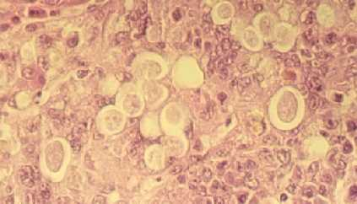

Histomonas

• Phylum Sarcomastigophora
Order Trichomonadida
Family
Monocercomonadidae
Histomonas meleagridis

Background

• -Histomonas meleagridis is a cosmopolitan parasite.
-It infects chickens, turkeys, peafowl, and pheasant.
-Causes a disease known as blackhead, infectious
enterohepatitis, or histomoniasis
-Disease effects turkey more than chickens

• This parasite causes great economic loss

• Definitive host(s): chicken, turkeys, peafowl, and pheasant

• Intermediate host: Heterakis gallinarum (a cecal nematode)

• Geographic Range: anywhere the definitive host are found

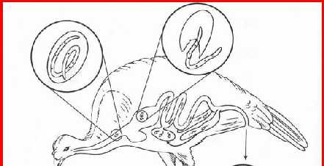

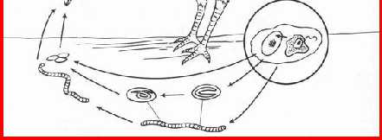

Morphology:

• -Environmental factors influence the size and shape of the parasite in its life stages.
-The life cycle does not have a cyst stage present.
-The parasite is found within the lumen of the cecum.
-Life stages are amoeboid 5 to 30 microns in diameter usually with one flagellum.
-The nucleus is vesicular and has a distinct endosome.
-There is a clear ectoplasm and granular endoplasm.
-Food vacuoles are present and may contain host blood cells.
-Sexual stages do not occur in the life cycle.
-Histomonas meleagridis divides by binary fission.

Life cycle

• -Being transported within the egg of H. gallinarum carries out transmission of H. meleagridis.
-It undergoes development and multiplication within H. gallinarum.
-H. meleagridis is ingested by the cecal nematode and the flagellates enter the nematode's
intestinal cells.
-Within the intestinal cells it will multiply then go to the pseudocoel and invade the
germinative area of the nematode's ovary.
-In the ovary it will feed and multiply, then migrate down the ovary and penetrate the
oocysts.
-H. meleagridis is passed out of the worm and the bird in the feces.
-Inside the egg it will penetrate juvenile nematode tissue.
-Infected nematode eggs can last up to two years in soil.
-The worm eggs are eaten by the proper definitive host and hatch in the intestine.
-The juvenile Heterakis migrates toward the cecum.
-Here Histomonas leaves Heterakis and resides in the host bird.
-Earthworms serve as a paratenic host for Heterakis and Histomonas.
-The earthworms will eat the nematode eggs.
-The eggs hatch releasing second stage juveniles that become dormant in the earthworm.
-When the earthworms are eaten by the bird, Heterakis juveniles are released causing
infection by two different parasites
• Heterakis eggs and infected earthworms survive long periods of time in the soil.

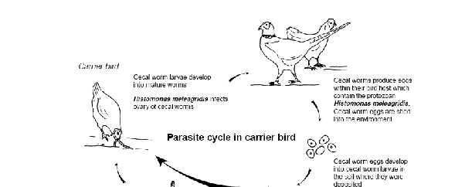

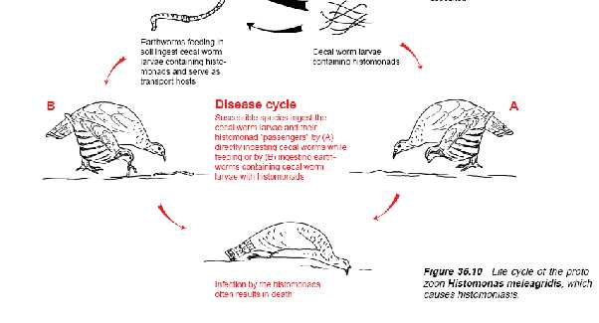

Life cycle

Pathogenesis

• -Turkeys are most susceptible between 3 and 12 weeks of age.
-Chickens are less likely to be infected by Histomonas
meleagridis.
-Lesions are present in the cecum and liver.
-Perforations of the cecum and peritonitis can occur.
-The cecum is enlarged and inflamed.
-Liver lesions will have white and green areas of necrosis.
-Symptoms of infected birds are droopiness, ruffled feathers,
yellowish diarrhea, hanging wings and tails.
-The skin on the head turns black is some instances (caused
by secondary bacterial infections).
-Birds that survive infection are immune for life

Dx, Rx & Cx

• Diagnosis
• -Detection of cecal and liver lesions
• Treatment
• -Use of nitroimidazoles and phenylarsonis acid derivatives.
-These suppress, inhibit, or cure the disease.
-To prevent future outbreaks the use of nematocides such as mebendazole, cambendazole, and levanisole are effective.
• Control
• -Keep young birds off the ground using hardware cloth or on dry ground.
-Control of Heterakis populations.

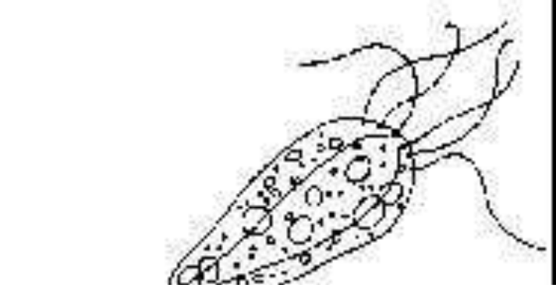

Hexamita

• Hexamita is a flagellated protozoan found in the gastrointestinal tracts of a variety of cold and warm water fish, including several species of Cichlids which are popular aquarium pets.

• Stress from malnutrition, shipping, over- crowding, or poor water quality may lead to rapid reproduction of the protozoan, resulting in disease.

• Three species of hexamita have been associated with disease in fish, Hexamita salmonis , Hexamita truttae and Hexamita intestinalis .

Transmission of hexamita

• Hexamita is probably transmitted through the water from contaminated fecal material.

• The flagellated stage makes its way to the lumen of the upper intestine.

• There it swims freely in the intestinal and cecal fluids.

• The organism may be present in small numbers under normal circumstances; however, for disease to develop the organism must reproduce rapidly resulting in a massive infestation.

• Generation time for the flagellated form is thought to be 24 hours.

Signs of hexamitiasis

• Weak or stressed fishes seem to be most susceptible to heavy infestation.

• Physical signs of hexamitiasis include weight loss, decreased activity and refusal of food.

• Angel fish which are severely infected with hexamita may lie horizontally on the surface of the water with the abdomen visibly distended.

• Angel fish may remain in this condition for several days. These severely infested fish often recover following treatment with metronidazole.

• Infestations in adult breeding angel fish may be associated with decreased hatchability of eggs or death of young fry.

Dx & Management

• Confirmation of hexamita infection is easily done by making a squash preparation of the intestine and examining it with a light microscope at
200 and 400x. The flagellates move rapidly and erratically.

• The recommended treatment for hexamita is metronidazole (Flagyl) administered in a medicated food or, if the fish are not eating, in a bath treatment. Metronidazole can be administered orally at a dosage of 50 mg/kg body weight (or 10 mg/gm food) for 5 consecutive days.

• If fish are already sick and off-feed metronidazole can be administered in a bath at a concentration of 5 mg/l (18.9 mg/gallon) every other day for three treatments.

Giardia

• - Giardiasis is a protozoal intestinal infection of humans and many domestic and other animals which occurs worldwide.

• The Giardia organism is a flagellated protozoan intestinal parasite with several morphological distinct species.

• Humans, dogs, cats, cattle and many other mammals may be infected with this parasite. Species names are currently under discussion and may change.

• Occurrence - Giardia spp. parasites occur in a wide range of mammals and birds. Water sources such as wells and streams may be contaminated with infective cysts. Cysts are resistant and can survive for long periods in moist environments outside the host.

History

• Single Cell Protozoa with 5 flagella
• Discovered in 1681 by Antony van Leeuwenhoek
• World Wide Distribution
• Giardia cysts have been identified in 2000 yr old human remains in Tennessee and Israel
• 2-4% prevalence in industrialized countries
• 15% or higher in developing countries
• Lives up to 2 months in cold water
• Colonizes in the intestines of mammals, birds, reptiles and amphibians
• Has causes epidemics in the US

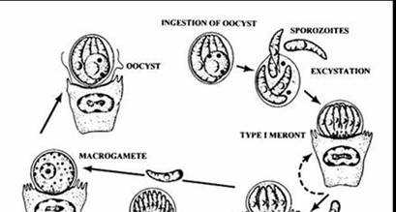

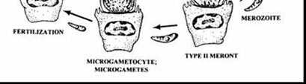

Life Cycle

• Giardia organisms occur in the two life stages, feeding trophozoites and environmentally resistant cysts.
• Cysts are ingested and trophozoites are released to feed on the surface of the microvilli lining the small intestine producing microscopic lesions on villi.
• The trophozoites multiply by binary fission.
• Encystation occurs in the lower intestinal tract and the immediately infective cysts are passed into the environment.

Clinical Features

• Giardia infection can cause a variety of intestinal symptoms, which include

• Diarrhea
• Gas or flatulence
• Greasy stools that tend to float
• Stomach cramps
• Upset stomach or nausea.
• These symptoms may lead to weight loss and dehydration.
Some people with giardiasis have no symptoms at all.

Pathology

• Actual disease mechanism is unknown.
• Many asymptomatic cases.
• More common in young animals and children.

• Most Frequent cause of non-bacterial diarrhea in the U.S.

• Normally illness lasts 1-2 weeks but chronic infections may occur.
• Can lead to malabsorption of nutrients

Diagnosis

• Fecal Flotation for detection of cysts.

• String Test (Human)

• Duodenal Wash (Canine)

• Fecal Wet Mount for trophozoites.

• In office ELISA Giardia Test—Idexx Lab
(antigen test)

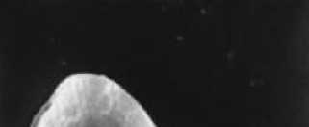

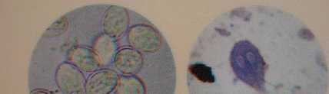

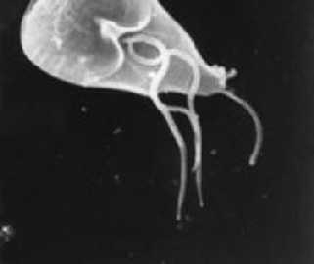

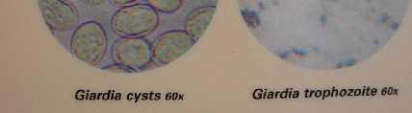

Trophozoites

Giardia Trophozoite

• ElectronMicrograph • Giardia Cysts and

Trophozoites do not survive long outside of the host

Treatment

• Metrondiazole
• Fenbendazole
• Prevention
Puppies—Common in “puppy mill” kennel situations.
Sanitation

• Humans—Normally thru contaminated water sources. Drink bottled water while abroad. Boil water on camping adventures.
• Water source filtration or chemical treatment.**
• Vaccination for pets is Available

Entamoeba histolytica

• Parasites assigned to the genus Entamoeba are single celled eukaryotes and parasitise all classes of vertebrates, a few invertebrates and possibly other unicellular eukaryotes also.

• All species have a simple life cycle that usually consists of an infective cyst stage and a multiplying trophozoite stage.

• Transmission of the infection occurs via ingestion of cysts in faecally contaminated food or water. Humans can be host to at least six species of

Trophozoite

• There are very few morphological criteria on which Entamoeba species identification can be based. Classically, descriptions of new Entamoeba species have relied on :

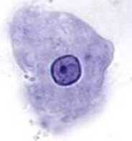

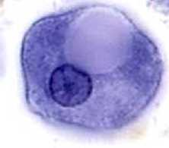

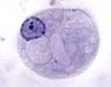

• The identity of the host
• The size of the trophozoite and cyst
• Nuclear morphology
• The number of nuclei in the mature cyst
• The morphology of what are known as chromatoid bodies that appear during encystation
• Central Endosome in nucleus

• Even chromatin clumps along edge of nucleus
nucleus

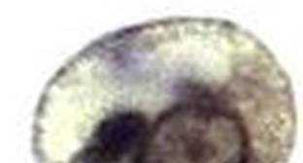

Entamoeba histolytica - Cyst

• Four or fewer nuclei

– You may have to focus to see all of them

– Images at left are the same cell, at different focal planes

• When present, chromatid bars (C) have rounded, blunt ends (below).

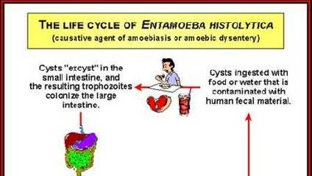

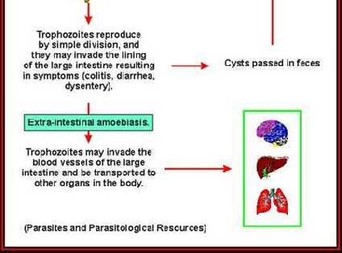

The life cycle

• The life cycle of Entamoeba histolytica involves trophozoites (the feeding stage of the parasite) that live in the host's large intestine and cysts that are passed in the host's feces.
• Humans are infected by ingesting cysts, most often via food or water contaminated with human fecal material.
• The trophozoites can destroy the tissues that line the host's large intestine, so of the amoebae infecting the human gastrointestinal tract, E. histolytica is potentially the most pathogenic.
• In most infected humans the symptoms of "amoebiasis" (or "amebiasis") are intermittent and mild (various gastrointestinal upsets, including colitis and diarrhea).
• In more severe cases the gastrointestinal tract hemorrhages, resulting in dysentery.
• In some cases the trophozoites will enter the circulatory system and infect other organs, most often the liver (hepatic amoebiasis), or they may penetrate the gastrointestinal tract resulting in acute peritonitis; such cases are often fatal. As with most of the amoebae, infections of E. histolytica are often diagnosed by
demonstrating cysts or trophozoites in a stool sample.

Leishmania

• Developmental stages of the genus are the amastigote form in vertebrates

• Promastigote form in the insect vector

• There are 2 main species; L. donovani and L.
Tropica

• The insect vector is Phlebotomus sp (sand-fly)

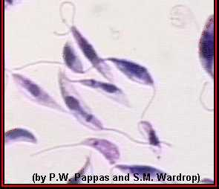

Promastigotes of Leishmania sp. from culture. This is the life cycle
stage that grows in the vector and that is injected into the human host when the
vector feeds. The promastigotes are approximately 25 µm in length.

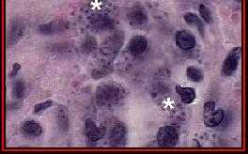

Amastigotes (*) of Leishmania donovani in the cells of a
spleen. The individual amastigotes measure approximately 1 µm in
diameter. The amastigotes reproduce asexually in these cells.

Amastigotes of Leishmania
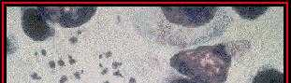

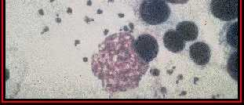

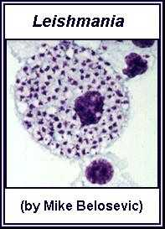

in a macrophage from a lymph node of
a dog.

Sandfly

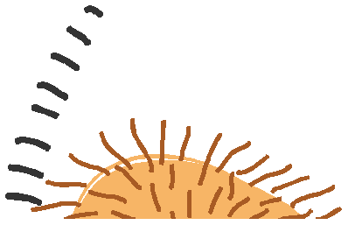

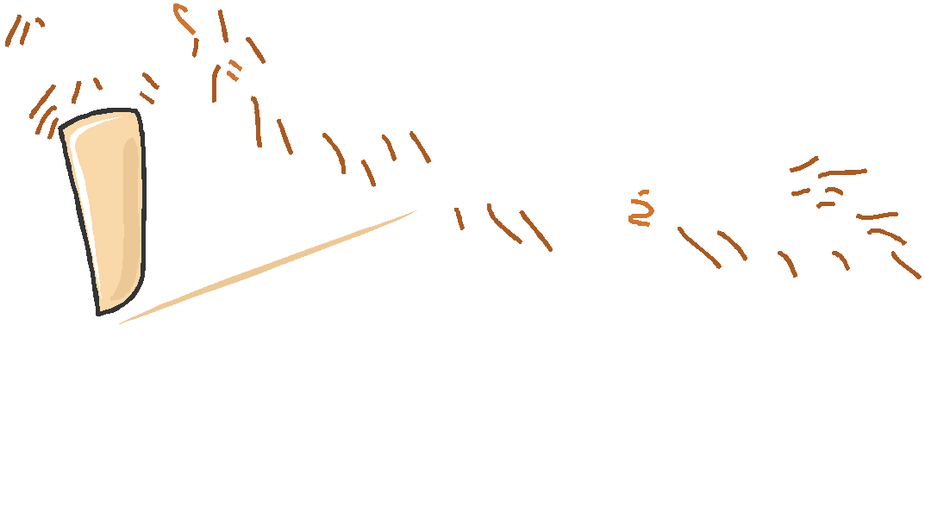

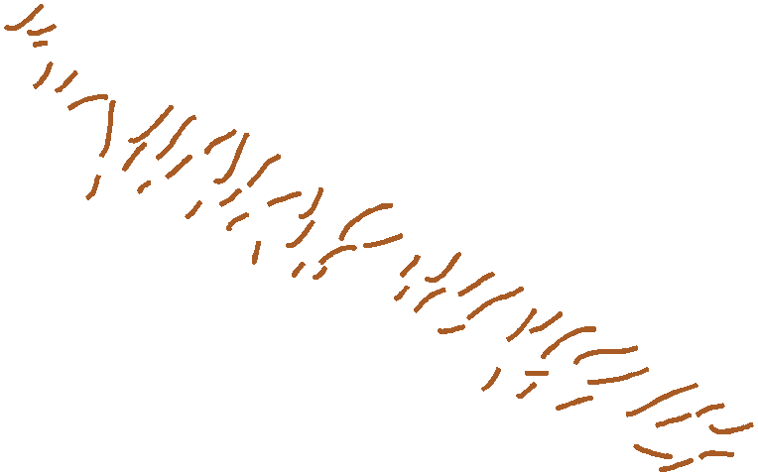

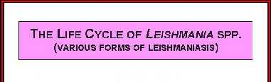

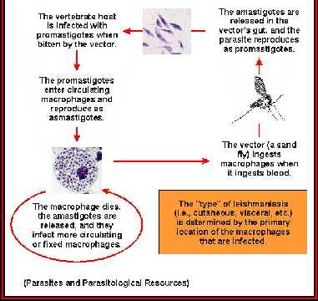

Life cycle of Leishmania spp.

Leishmania donovani:

• Causes visceral leishmaniasis (kala-azar, dumdum fever)

• Frequently fatal in man. Invade liver, spleen, bone marrow, destroying the macrophages

• Disease is similar in dogs

Leishmania tropica:

• Causes cutaneous leishmaniasis (Oriental sore, Aleppo button)

• Man is the usual host

• Found in West Africa, Middle East, Asia

• Appears as reddish papule – shallow ulcer –
ulcer enlarges & merge to form larger ulcer

Diagnosis:

Visceral leishmaniasis: By demonstration of organisms in spleen, liver, lymph node, bone marrow after biopsy

Cutaneous leishmaniasis: Demonstration of organisms in specimens from edge of ulcer or local lymph node

A cutaneous leishmaniasis lesion on
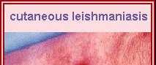

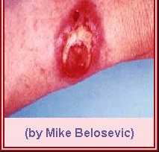

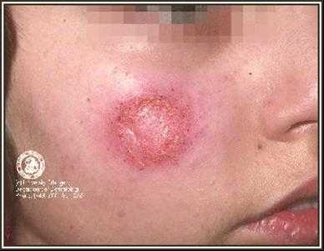

the arm.

Trypanosoma

• Occur in blood and tissue fluids or tissues of vertebrates (Brucei group)

• Transmitted by blood-sucking arthropods

• Cyclical development may be (i) anterior
Station or (ii) posterior station

• Any trypanosome can be transmitted mechanically e.g. by blood sucking insects

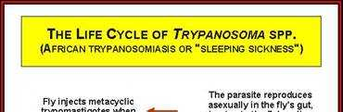

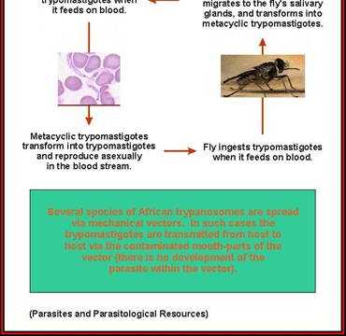

Life cycle of Trypanosoma spp.

Subgenus Duttonella;

Kinetoplast terminal, posterior end of body rounded, non-prominent undulating membrane, free
flagellum, great motility, development in proboscis of
Glossina only e.g. T. vivax, T. Unforme
Subgenus Nannomonas;

Kinetoplast marginal, small size, no free flagellum, moderate undulating membrane, development in mid-gut and then proboscis of Glossina e.g. T. congolense, T. simiae

Subgenus Trypanozoon;

Kinetoplast small & subterminal, undulating membrane well developed, monomorphic or polymorphic ( long, intermediate or stumpy forms with long free, short free & no flagellum respectively), development in mid-gut & proboscis e.g. T. brucei, T. gambiense, T. rhodesinse

Trypanosoma vivax;
Posterior part distinctly broad & bulbous, kinetoplast large & terminal, flagellum free & short. Very motile in fresh blood (moving rapidly under microscope).

Hosts are cattle, sheep, goat, camels, horses, buffalo. Dogs & pigs refractory to infection

Causes the most important form of trypanosomosis of cattle in West Africa. May cause acute, peracute or chronic disease

Causes mortality in sheep & goats; chronic disease in horses

Trypanosoma congolense;

Smallest of the African trypanosomes, posterior end blunt, kinetoplast marginal, no free flagellum, marked but no progressive movement in fresh blood

Hosts include ALL domestic animals. Principal cause of ‘nagana’ in cattle (Undulating disease). Similar disease in sheep & goats). Can cause acute disease in dogs (anaemia, icterus, keratitis, subcutaneous oedema etc). Chronic disease in horses (anaemia, weakness, oedema of legs and genitalia)

Trypanosoma simiae;

Resembles T.congolense. Natural host is the warthog.
Causes very acute and fatal disease in pigs.

Trypanosoma brucei;

Polymorphic; slender, intermediate & stumpy forms occur. All forms may occur in blood simultaneously. Movement is snake-like (wriggling) in fresh blood. Found in plasma & intercellular tissue fluids

Hosts include horses, cattle, sheep, goats, dogs

T. brucei (contd);

Most cause severe infection in horses (acute or chronic); intermittent fever, emaciation, ocular & nasal discharge, anaemia, subcutaneous oedema

In cattle & sheep, localize extravascularly; inflammatory reactions in skin, heart, CNS & eye. Mixed infection with T. Vivax & T. Congolense

In dogs & cats; Often acute fever, emaciation, oedema of eye lids & thorax

T. gambiense and T. Rhodesiense

Cause sleeping sickness in man in West Africa and southern Africa respectively

T. Equiperdum ; Causes venereal disease of horses
(dourine) in North & South Africa, Central & South
America, Middle East. Transmitted by coitus

T. cruzi; Chagas disease or American human trypanosomosis. In South America. Transmitted by blood sucking bugs of the family Reduviidae. Metacyclic forms passed in faeces of bugs & rubbed by hand into wounds made by the bugs

Pathogenicity
• Disease produced by T. Vivax & T. Congolense essentially due to anaemia

• Disease produced by T. brucei due to anaemia, tissue degeneration and inflammatory changes

• Anaemia due to haemolysis, erythrophagocytosis and haemodilution.

• T. gambiense & T. rhodesiense enter the cerebrospinal fluid = ‘Sleeping sickness’
• T. equiperdum; frequent urination & abortion

Treatment: Drugs commonly used belong to 4 groups;

Diamidine group; Diminazene aceturate (Berenil) Sulphonated naphthylamine; Suramin Phenanthridine; Homidium bromide or chloride
6-Aminoquinaldine; quinapyramine di-methylsulphate

Epimastigotes of Trypanosoma grown in culture; in this form the kinetoplast (KP) is anterior to the nucleus (N). In most species of Trypanosoma, this is
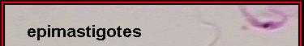

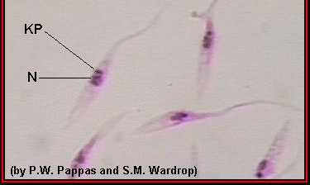

the life cycle stage that reproduces in the gut of the vector. The epimastigotes measure approximately 30 µm in length.

Trypomastigotes of Trypanosoma in a blood smear; in this form the kinetoplast is posterior to the nucleus. This life cycle stage is found in all species of

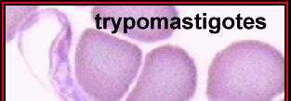

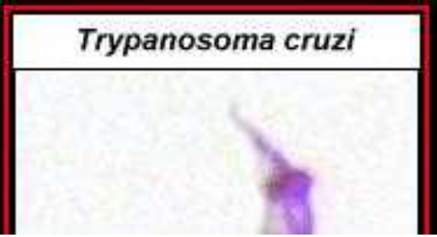

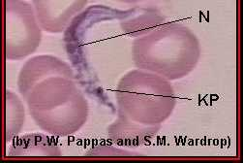

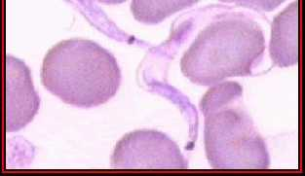

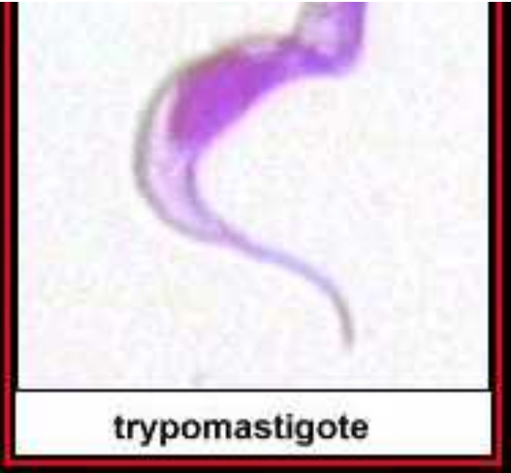

Trypanosoma, and in most species it is the only stage that reproduces in the vertebrate (human) host.

Trichomonas

Important species are:
Trichomonas foetus;
• Parasite of cattle; causes a venereal disease
• Organism is pear-shaped with 3 anterior flagella
• Transmission is by coitus & artificial insemination
• In bull, predilection site is preputial cavity
• In cow, vaginitis, invasion of uterus, placentitis, abortion, sterility

• Diagnosis based on demonstration of organisms in preputial washing, vaginal or uterine discharges or in aborted foetus

Trichomonas vaginalis;

• Occurs in humans

• Found in the vagina, urethra and prostate glands

• Transmitted by coitus, contaminated toilet seats, under-wears, towels etc

• In males, often symptomless. In females, vaginitis etc

• Diagnosis by detection of parasites in vaginal or prostatic secretions

• Metronidazole is very effective for treatment

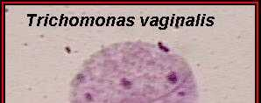

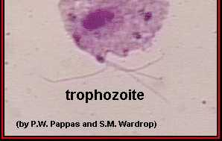

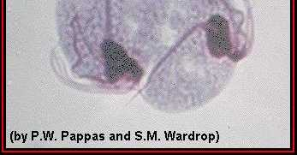

A trophozoite of Trichomonas vaginalis from culture. The four
flagella and single nucleus are visible. The dark median rod is the axostyle which is
characteristic of the trichomonads; approximate size = 26 µm.

Plasmodium

This genus contains the malarial organisms of man, other mammals and vertebrates

Species that infect birds include P. gallinaceum, P. relictum, P. elongatum etc

Species that infect man include P. falciparum, P. malariae, P. ovale and P. vivax

Vectors of mammalian sp are anopheline mosquitoes and for avian sp are culicine mosquitoes

Anopheles

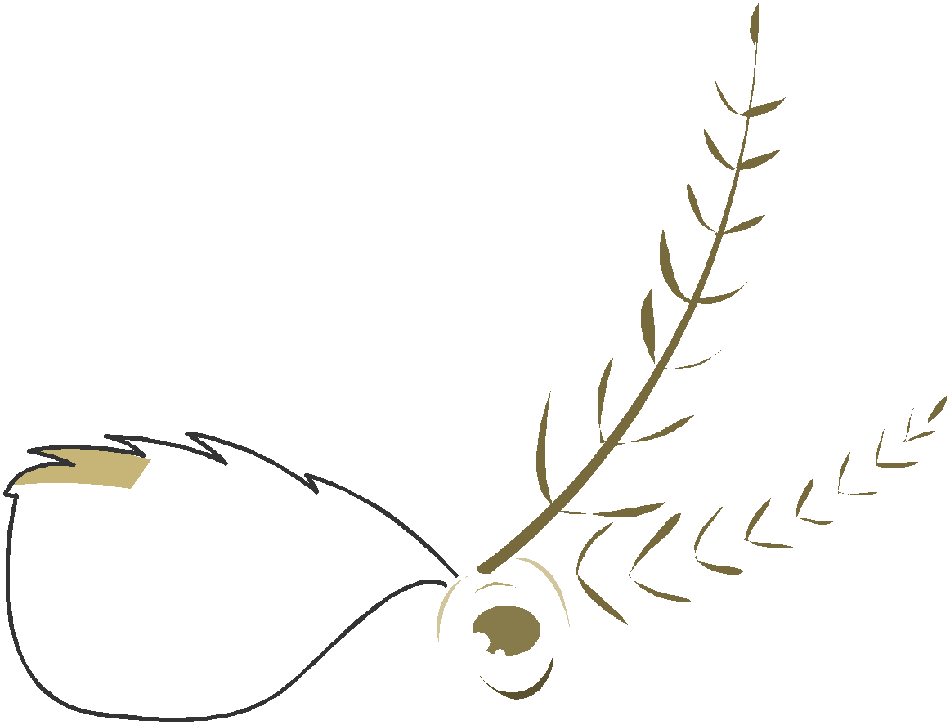

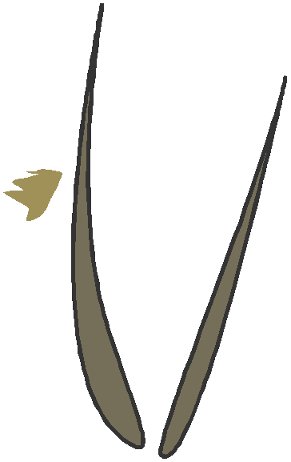

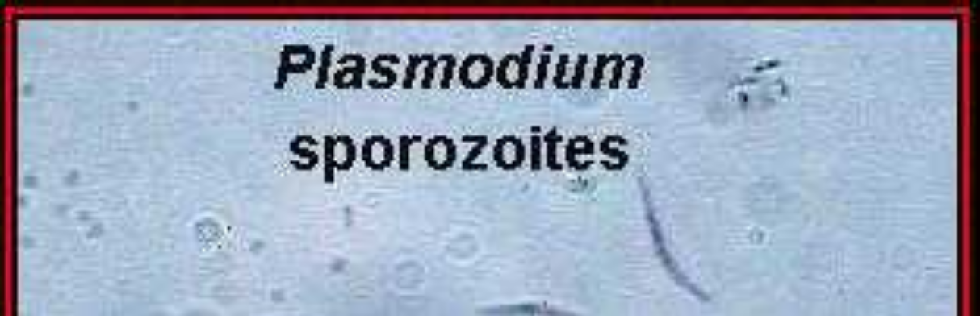

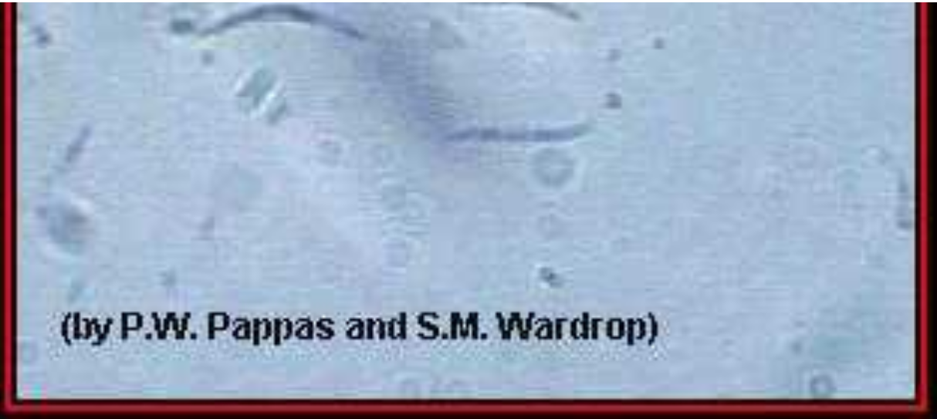

Sporozoites of Plasmodium; approximate length of each = 10 µm. This life
cycle stage is produced by the oocyst (see below), migrates to the mosquito's
salivary glands, and is injected when the mosquito feeds.

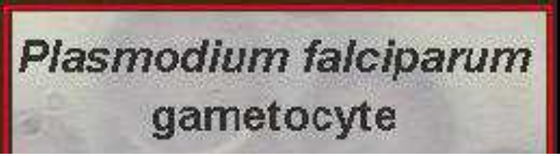

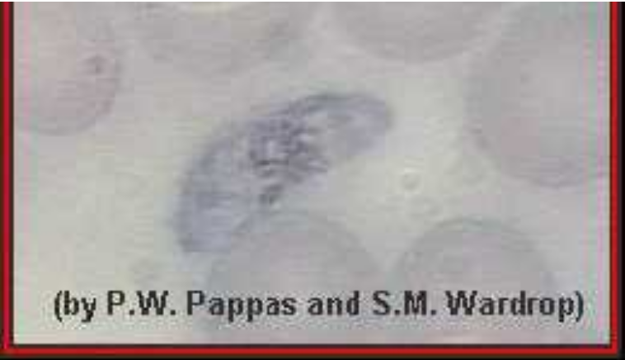

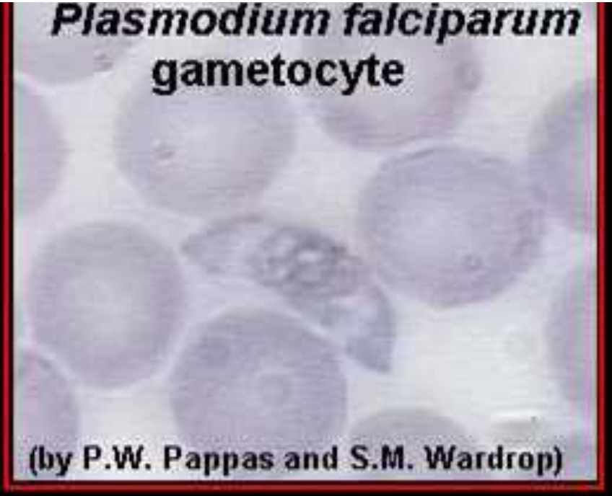

Gametocytes of Plasmodium falciparum in a blood
smear. Note the characteristic shape.

Ring stages of Plasmodium
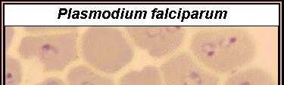

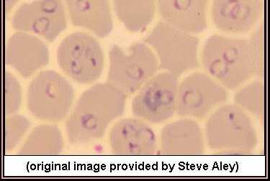

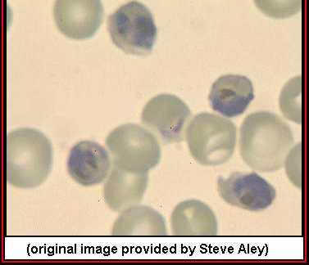

falciparum. Note the multiple
infections of some cells.

Plasmodium falciparum trophs and
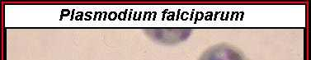

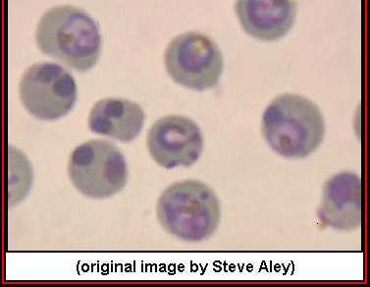

early schizonts.

Oocysts of Plasmodium on the surface of a mosquito gut. The dark material is partially digested blood inside of the
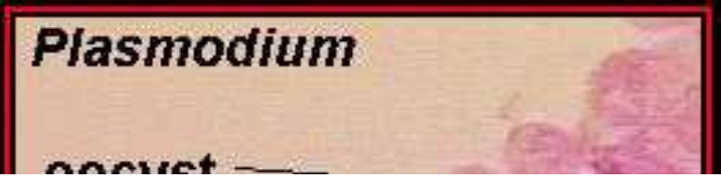

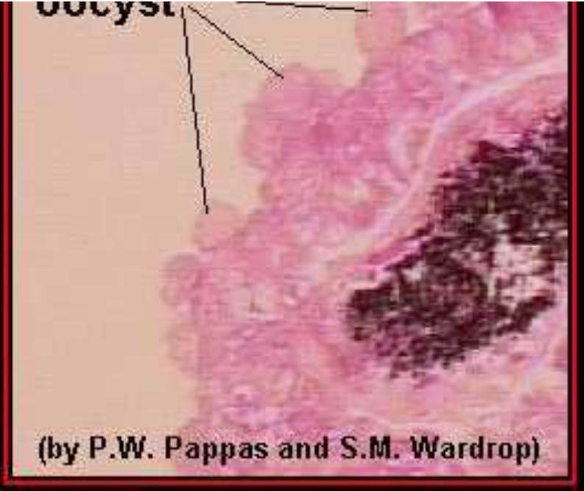

mosquito gut.

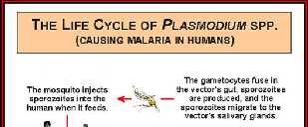

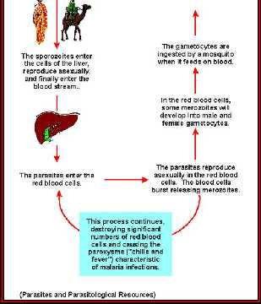

Life cycle of Plasmodium spp.

Haemoproteus

This genus is widespread in birds and also in reptiles.
They are transmitted by hippoboscid flies and some
cases by Culicoides

Haemoproteus columbae; Hosts are pigeons and doves.
Gametocytes occur in erythrocytes. Schizogony in
endothelial cells of blood vessels.

Pathogenicity is low

Haemoproteus meleagridis; Hosts are turkeys.
Pathogenicity low

Hepatozoon

Schizogony occurs in the endothelial cells of the liver and gametocytes are found in leucocytes or erythrocytes depending on the species

Hepatozoon canis; Hosts are dog, cat, jackal, hyena. Clinical signs are intermittent fever, anaemia,
emaciation. Death occurs 4-8 weeks after onset of
clinical signs

Hepatozoon cuniculi; Found in rabbits

