INTRODUCTORY AGRICULTURAL BIOCHEMISTRY
ANN 202
Carbohydrate
DEFINITION: carbohydrates are derivative of aldehydes and ketones. They are polyhydroxyl in nature. On hydrolysis they yield these compounds
Carbohydrates are grouped into 4 main classes: Monosaccharides, Disaccharides, Oligosaccharides and Polysaccharides.
Monosaccharides
Monosaccharides are the most basic units of biologically important carbohydrates. They are the simplest form of sugar and are usually colorless, water-soluble, crystalline solids. Some monosaccharides have a sweet taste. Examples of monosaccharides include glucose (dextrose), fructose (levulose), galactose, xylose and ribose. Monosaccharides are the building blocks of disaccharides such as sucrose and polysaccharides (such as cellulose and starch). Further, each carbon atom that supports a hydroxyl group (except for the first and last) is chiral, giving rise to a number of isomeric forms all with the same chemical formula. For instance, galactose and glucose are both aldohexoses, but have different chemical and physical properties.
Monosaccharides can be categorized according to their value of 'n,' (number of carbon atom) as shown below:
n | Category
3 | Triose
4 | Tetrose
5 | Pentose
6 | Hexose
7 | Heptose
8 | Octose
Monosaccharides can exist as aldehydes (CHO or H C=O) or ketones (CO or C=O) and are called aldoses or ketoses, respectively. For example, below are the structures of glyceraldehyde, an aldo-triose, and dihydroxyacetone, a keto-triose. Glyceraldehyde and dihydroxyacetone have the same atomic composition, but differ only in the position of the hydrogens and double bonds.
Carbons in a monosaccharide are numbered such that the aldehyde group is carbon number one or the ketone group is carbon number two.

Aldoses
Aldotriose | 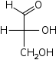  D-Glyceraldehyde
Aldotetroses | 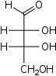  D-Erythrose |  |  |  |  | 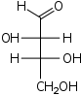  D-Threose
Aldopentoses | 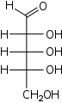  D-Ribose |  |  |  | 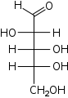  D-Arabinose | 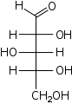  D-Xylose |  | 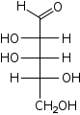  D-Lyxose
Aldohexoses |  |  | 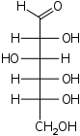  D-Glucose | 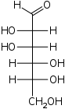  D-Mannose |  | 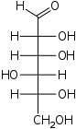  D-Gulose | 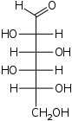  D-Idose | 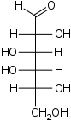  D-Galactose

Ketoses
Ketotriose | 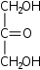  Dihydroxyacetone
ketotetrose | 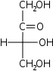  D-Erythrulose
ketopentoses | 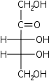  D-Ribulose |  | 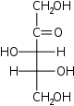  D-Xylulose
ketohexoses | 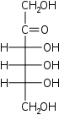  D-Psicose | 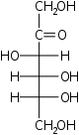  D-Fructose | 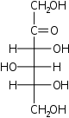  D-Sorbose | 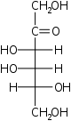  D-Tagatose

Isomerism
The total number of possible stereoisomers of one compound (n) is dependent on the number of stereogenic centers (c) in the molecule. The upper limit for the number of possible stereoisomers is n = 2^{c}. The only monosaccharide without an isomer is dihydroxyacetone or DHA.
Monosaccharides are classified according to their molecular configuration at the chiral carbon furthest removed from the aldehyde or ketone group. The chirality at this carbon is compared to the chirality of carbon 2 on glyceraldehyde or the penultimate chiral carbon of any monosaccharide. If it is the OH of the penultimate carbon rotate to the right equivalent to D-glyceraldehyde's C2, the sugar is D; if it is equivalent to L-glyceraldehyde's C2, the sugar is L. Due to the chirality of the sugar molecules, an aqueous solution of a D or L saccharides will rotate light. D-glyceraldehyde causes polarized light to rotate clockwise (dextrorotary); L-glyceraldehyde causes polarized light to rotate counterclockwise (levorotary). Unlike glyceraldehyde, D/L designation on more complex sugars is not associated with their direction of light rotation. Since more complex sugars contain multiple chiral carbons, the direction of light rotation cannot be predicted by the chirality of the carbon that defines D/L nomenclature.
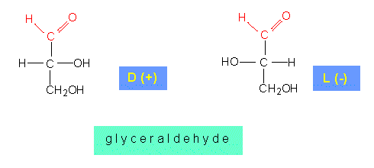
Sugar Ring Structures
When sugars cyclize, they typically form furanose or pyranose structures. These are molecules with five-membered or six-membered rings, respectively. Cyclization creates a carbon with two possible orientations of the hydroxyl around it. Cyclization of an aldose occurs by intramolecular reaction with the aldehyde and alcohol groups to form a hemiacetal. Cyclization of a ketose occurs by intramolecular reaction with the ketone and alcohol groups to form a hemiketal. In either case, a new asymmetric carbon is created by the reaction and we refer to the carbon as the anomeric carbon and the two possible configurations as anomers. The two possible configurations of the hydroxyl group are called alpha and beta, which correspond to the hydroxyl being in the "down" and "up" positions, respectively, in standard projections. Anomers are capable of interconverting between alpha and beta positions in a process are called mutarotation IF the hydroxyl group of the hemiacetal or hemiketal is unaltered.
.
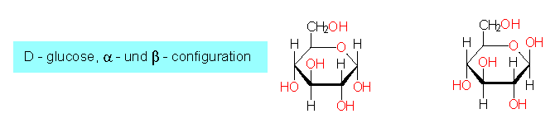

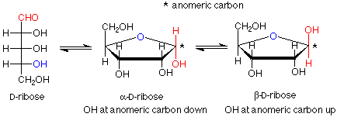
Epimers: They are a special case of diastereoisomerism where there is a difference for one and only one asymmetric center. e.g. D-glucose and D-mannose; D-glucose and D-galactose are epimers.
epimer, is used to designate diastereomers that differ in configuration at only one chiral center. Thus, ribose and arabinose are epimers at C-2, and arabinose and lyxose are epimers at C-3. However, arabinose and xylose are not epimers, since their configurations differ at both C-2 and C-3.
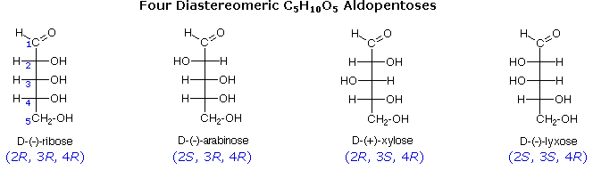

Amino Sugars - made by replacing a hydroxyl of a sugar with an amine group. Two common examples are beta-D-glucosamine and beta-D-galactosamine. Common molecules derived from these include beta-D-N-acetylglucosamine, muramic acid, N-acetylmuramic acid, -D-N-acetylgalactosamine, and N-acetyl-neuraminic acid (also called sialic acid). Amino sugars are often found in oligosaccharides and polysaccharides. It is significant in several biological systems.It is part of a biopolymer in the bacterial cell wall, GlcNAc is the monomeric unit of the polymer chitin, which forms the outer coverings of insects and crustaceans. GlcNAc is also of note in neurotransmission, where it is thought to be an atypical neurotransmitter functioning in nocioceptive (pain) pathways. It has been proposed as a treatment for autoimmune diseases.
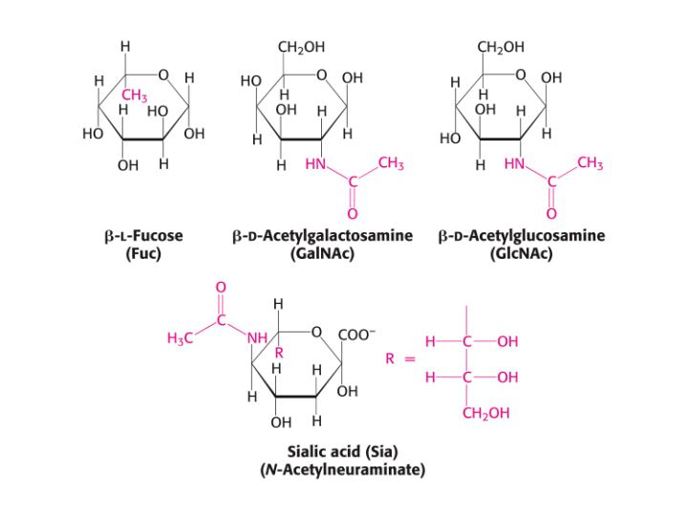

Disaccharide
is the carbohydrate formed when two monosaccharides undergo a condensation reaction which involves the elimination of a small molecule, such as water, from the functional groups only. Like monosaccharides, disaccharides also dissolve in water, taste sweet and are called sugars. There are two basic types of disaccharides: reducing disaccharides, in which the monosaccharide components are bonded by hydroxyl groups; and non-reducing disaccharides, in which the components bond through their anometric centers.
It is formed when two monosaccharides are joined together and a molecule of water is removed. For example; milk sugar (lactose) is made from glucose and galactose whereas cane sugar (sucrose) is made from glucose and fructose.
The two monosaccharides are bonded via a dehydration reaction (also called a condensation reaction or dehydration synthesis) that leads to the loss of a molecule of water and formation of a glycosidic bond.

Common disaccharides
Disaccharide | Unit 1 | Unit 2 | Bond
Sucrose (table sugar, cane sugar, saccharose, or beet sugar) | glucose | fructose | α(1→2)
Lactulose | galactose | fructose | β(1→4)
Lactose (milk sugar) | galactose | glucose | β(1→4)
Maltose | glucose | glucose | α(1→4)
Trehalose | glucose | glucose | α(1→1)α
Cellobiose | glucose | glucose | β(1→4)

Maltose
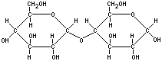

Sucrose
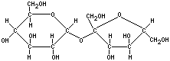
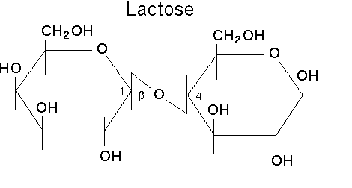
Oligosaccharides are also found as part of glycoproteins and play a role in cell recognition/identity. Oligosaccharides form the blood group antigens. In some cells, these antigens are attached as O-linked glycans to membrane proteins. Alternatively, the oligosaccharide may be linked to a lipid molecule to form a glycolipid. These oligosaccharides determine the blood group types in humans.
Sucrose is a precursor to a group of carbohydrates in plants known as the raffinose family of oligosaccharides found in many plant seeds especially legumes. This family contains the trisaccharide raffinose, the tetrasaccharide stachyose and the pentasaccharide verbascose:
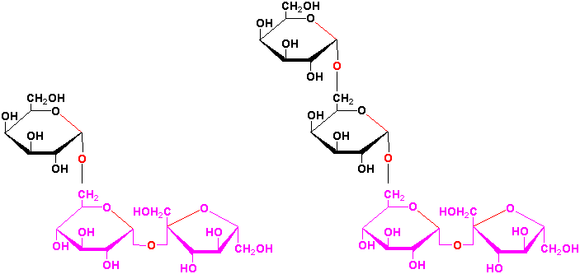

Oligosaccharides play a role in cell recognition/identity. Oligosaccharides form the blood group antigens) by linkage to proteins in blood cell membranes forming glycoproteins or, in some cases, to lipids, forming glycolipids. Three different oligosaccharide structures give rise to the blood groups - A, B, and O. The base structure of each contains the structure of the O antigen. Specific glycosyltransferases add the extra monosaccharide to the O antigen to give rise to either the A or B antigen.
Polysaccharides
Polysaccharides are polymers of monosaccharide units. The monomeric units of a polysaccharide are usually all the same (called homopolysaccharides (polymer of one sugar)), though there are exceptions (called heteropolysaccharides (more than one sugar in polymer chain)
In some cases, the monomeric units are modified monosaccharides. Polysaccharides differ in the composition of the monomeric unit, the linkages between them, and the ways in which branches from the chains occur. Common polymers, their monomeric units, and linkages/branches are shown below:
Polysaccharide Name | Monomeric Unit | Linkages
Glycogen | D-Glucose | alpha 1->4 links with extensive alpha1->6 branches
Cellulose | D-Glucose | beta 1->4
Chitin | N-Acetyl-D-glucosamine | beta 1->4
Amylopectin | D-Glucose | alpha 1->4 links with some alpha 1->6 branches
Amylose | D-Glucose | alpha 1->4
Linkages between the individual units require special enzymes to break them down. For example, the alpha 1-> 4 linkages between glucose units in glycogen, amylose, and amylopectin, are readily broken down by all animals, but only ruminants (cows) and related animals contain symbiotic bacteria with an enzyme (cellulase) that can break down the beta 1-> 4 linkages between individual glucose units in cellulose. As a result, the huge amount of cellulose in the biosphere is unavailable as an energy source to most animals.
Storage Polysaccharides
Polysaccharides are used to some extent for energy storage in almost all higher organisms. Plants use starch, Starches are insoluble in water and thus can serve as storage depots of glucose. Plants convert excess glucose into starch for storage. Rice, wheat, and corn are also major sources of starch in the human diet.

Starch composed of amylose and amylopectin
- amylose consists of linear, unbranched chains of several hundred glucose residues (units). The glucose residues are linked by a glycosidic bond between their #1 and #4 carbon atoms.
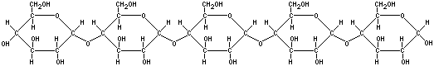
- amylopectin differs from amylose in being highly branched. At approximately every thirtieth residue along the chain, a short side chain is attached by a glycosidic bond to the #6 carbon atom (the carbon above the ring). The total number of glucose residues in a molecule of amylopectin is several thousand.
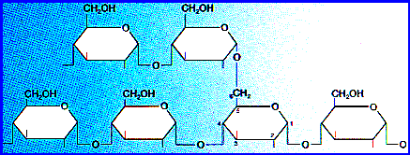

Glycogen
Animals store excess glucose by polymerizing it to form glycogen. The structure of glycogen is similar to that of amylopectin, although the branches in glycogen tend to be shorter and more frequent. Glycogen is broken back down into glucose when energy is needed (a process called glycogenolysis). The liver and skeletal muscle are major depots of glycogen.
Structural Polysaccharides
plants use different polysaccharides, such as cellulose, for structural purposes in their cell walls. The exoskeleton of many arthropods and mollusks is composed of chitin, a polysaccharide of N-acetyl-D-glucosamine.

Cellulose
Cellulose is probably the single most abundant organic molecule in the biosphere. It is the major structural material of which plants are made. Wood is largely cellulose and lignin while cotton and paper are almost pure cellulose. Cellulose is derived from D-glucose units, which condense through β(1→4)-glycosidic bonds. Cellulose is a straight chain polymer: unlike starch, no coiling or branching occur Cellulose is a polymer made with repeated glucose units bonded together by beta-linkages. Humans and many other animals lack an enzyme to break the beta-linkages, so they do not digest cellulose. Certain animals can digest cellulose, because bacteria possessing the enzyme cellulose are present in the gut. Classical examples are ruminant and termites.
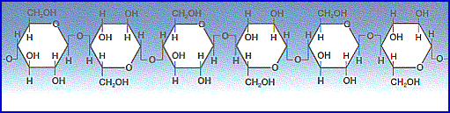

Hemicellulose
Hemicellulose is a polysaccharide related to cellulose that comprises ca. 20% of the biomass of most plants. In contrast to cellulose, hemicellulose is derived from several sugars in addition to glucose, including especially xylose but also mannose, galactose, rhamnose, and arabinose. Hemicellulose consists of shorter chains - around 200 sugar units. Furthermore, hemicellulose is branched, whereas cellulose is unbranched.
Chitin

is a homopolymer of N-acetyl-D-glucosamine, with units joined by beta 1-> 4 bonds. Chitin is found in organisms as diverse as algae, fungi, insects, arthropods, mollusks, and insects. Chitin is a long-chain polymer of a N-acetylglucosamine, a derivative of glucose, and is found in many places throughout the natural world. It is the main component of the cell walls of fungi, the exoskeletons of arthropods such as crustaceans (e.g. crabs, lobsters and shrimps) and insects, the radulas of mollusks and the beaks of cephalopods, including squid and octopuses. Chitin has also proven useful for several medical and industrial purposes. Chitin may be compared to the polysaccharide cellulose and to the protein keratin. Although keratin is a protein, and not a carbohydrate like chitin, keratin and chitin have similar structural functions.

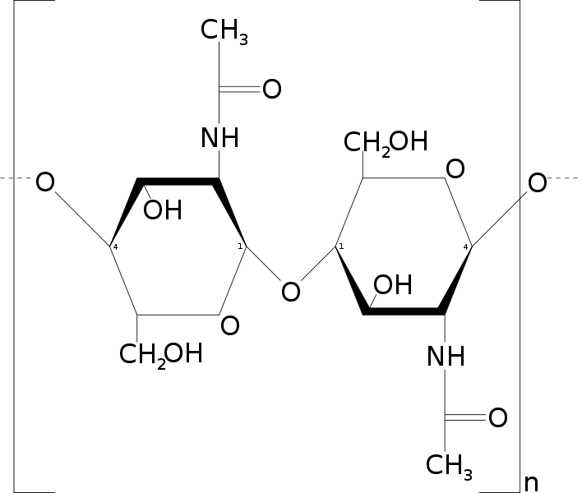N-acetylglucosamine

Uses

Agriculture
Most recent studies point out that chitin is a good inducer for defense mechanisms in plants.^{[4]} It was recently tested as a fertilizer that can help plants develop healthy immune responses, and have a much better yield and life expectancy.^{[5]} The Chitosan is derived from chitin, which is used as a biocontrol elicitor in agriculture and horticulture.

Industrial
Chitin is used industrially in many processes. It is used in water purification, and as an additive to thicken and stabilize foods and pharmaceuticals. It also acts as a binder in dyes, fabrics, and adhesives. Industrial separation membranes and ion-exchange resins can be made from chitin. Processes to size and strengthen paper employ chitin.

Medicine
Chitin's properties as a flexible and strong material make it favorable as surgical thread. Its biodegradibility means it wears away with time as the wound heals. Moreover, chitin has some unusual properties that accelerate healing of wounds in humans.^{[7]}

.

